**RESUME**

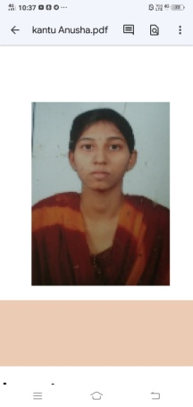

**KANTU ANUSHA**

**Address:**-H No: 2-56,Venkatrampuram(V),

Ananthagiri(M),Suryapet(Dist.),

Telangana,508206

**Email id:**-kantuanusha107@gmail.com

**Mobile No:** 6304253608

**PROFFESSIONAL SUMMARY:**

To work with best of my abilities and skills in order to benefit my organization also to be better other in this competitive time an influential position in the organization.

**SKILLS:**

* Good communication skills

**Experience:**

* B tech fresher

**EDUCATION:**

|  |  |  |  |
| --- | --- | --- | --- |
| **Qualification** | **Institute** | **CGPA** | **Year of passing** |
| B.Tech (EEE) | Kodada Institute Of Technology and Science for Women | 70 | Pursuing |
| Diploma (EEE) | Anurag Engineering collage | 63.92 | 2020 |
| S.S.C | Pragathi new vision school | 7.7 | 2017 |

**TECHNICAL SKILLS:**

* MS office
* C language

**PERSONAL DETAILS:**

Father’s Name : Kantu Venkateswarlu

Date of birth : 03 march2002

Languages known : English (intermediate)

Telugu

Marital status : Single

**DECLARATION :**

I hereby declare that above written particulars are true to be the best of my knowledge and belief.

K.Anusha